Project Datasets submission form
Academic Year: 22-23
Student Name: 2
Project Title: Does Noise Affect How Children Learn Grammar in the Classroom?
Supervisor Name: Hannah Stewart
Abstract:
In a classroom environment noise can be a significant impediment, obstructing and distorting essential information being taught. Extensive prior research consistently indicates that noise has a detrimental impact on learning, those who learn in noise retain and comprehend far less information than their counterparts who learn in quiet. To date there are no studies that investigate the effect of noise on learning grammar specifically -the primary aim of the current study is the address this research gap. This paper details our recruitment of 16 children aged 7– 12 through the Babylab database at Lancaster university. This study employed a between participants design, where children completed a three-part audio evaluation, engaged in an artificial grammar paradigm, and a undertook a working memory task. The artificial grammar paradigm was employed as our primary assessment tool, participants were exposed to the grammar either in noise or in quiet. Results were analysed using a multiple regression with total grammar score as the dependent variable and age, gender, condition, and working memory as the independent variables. In contrast the prior research, our results revealed that the effect of the independent variables on the dependent variable was statistically nonsignificant, proving our null hypotheses to be true. These findings suggest that background noise does not affect how children learn grammar in the classroom challenging the existing understanding that noise negatively impacts learning.
Methods Section:
Participants
16 children aged 7-12 years old participated in this study, unfortunately due to technical
issues 5 participants’ data were excluded leaving 11 children’s data to be included in the
analysis (M=8.64, SD=1.63, female=7, male=4). Children were recruited through the Lancaster
University Babylab database and by flyers posted on social media and local community.
A requirement of the current study was that children be English speaking monolinguals,
this is because an abundance of research has indicated that those who can speak two or more
languages are at a far greater advantage when it comes to new language acquisition (Antoniou
et al., 2015). Therefore, in order to control the likelihood of extraneous variables such as this
we ensured all participants were English speaking monolinguals only.
Furthermore, children were also required to have normal vision or corrected to normal
vision. To rule out hearing loss all children had to pass an otoscope inspection, a
tympanometry test, and a pure tone hearing screening at 20dB in the standard frequencies
(250Hz-8kHZ).
The current study employed a between participant design whereby subjects were
allocated to a condition based on their age and gender -age was categorised into 7-9 and 10-12-
in order to ensure that there were as equal an amount of males and females in each condition
over all ages. It is crucial for the validity of the study that children are only exposed to the
artificial grammar paradigm once or data will be rendered unreliable as they will have an unfair
advantage over the other participants.
Ethics for the current study have been obtained from the Departmental Ethics
Committee (DEC), Psychology Department at Lancaster University.
Materials
This study was conducted within a double walled soundproof chamber at Lancaster
University’s PELiCAN lab where the participant sat at a desk with a monitor placed in front of
them. A secondary researcher was present in the lab for health and safety purposes.
Consent and assent forms, a background questionnaire on the child’s hearing, audio
evaluation results, and task data were all recorded on REDCap (Harris et al., 2009; Harris et
al., 2019): a GDPR compliant application for data capture.
Travel compensation was provided: £5 within 40 minutes and £10 for over 40 minutes.
Furthermore, children received a certificate and book of their choosing from the PELiCAN lab.
The audio evaluation
This study was comprised of three sections: an audio evaluation whereby an otoscope
examination, tympanometry test, and audiogram using Affinity Suite were conducted. During
the audiogram participants wore headphones and had a handheld button that they pressed when
they heard the pure tone sounds.
The Artificial Grammar Paradigm
After passing the hearing evaluation the children completed an artificial grammar
paradigm previously used by Torkildsen et al. (2013) consisting of two grammatical forms: aX
and Yb. The paradigm was presented in the form of an alien game whereby the children helped
an alien learn a new language. We presented the paradigm in this format in order to increase
engagement; children are motivated by the colourful and curious nature of a game (Blumberg
et al., 2019) and therefore we are far more likely to obtain more data (less drop outs due to
fatigue and boredom). This task was created in PsychoPy and hosted by Pavlovia.
The background noise
In order to imitate the background noise of a classroom speech shaped noise (SSN)
(e.g. Leibold et al., 2013) was emitted through a speaker on the back wall of the booth behind
the child. The background noise speaker was 180 degrees on the azimuth, and the target
speaker was 0 degrees on the azimuth. Background stimuli was calibrated so that for the quiet
condition the stimulus was emitted at 35dB and for the noisy condition it was played at 65dB.
The n-back Test of Working Memory
Lastly, we conducted the 1-back test of working memory (Owen et al., 2005) which
was also created on PsychoPy and hosted by Pavlovia
Procedure
Prior to the commencement of the study guardians gave informed consent (See
Appendix C), if the child was 11 or older they gave informed assent in addition to this (See
Appendix D). Guardians were then asked to complete a short background questionnaire
pertaining to their child’s hearing (See Appendix H). Whilst they completed these forms the
researcher began the study inside the booth; using Affinity suite it was ensured that the
microphone inside the booth was turned on in order for the guardian to be able to hear what
was going on inside the booth by using the headphones places outside the booth.
As aforementioned, the audio evaluation consisted of three tests, these were
administered in the booth by the researcher and took up to 15 minutes. Firstly, an ear
inspection was conducted using an otoscope, participants were required to have clear ears free
of perforations and/or any infection. Secondly, a tympanometry test was conducted whereby
participants must have passed with type A (normal) results. Lastly a pure tone hearing
screening was conducted at 20dB in the standard frequencies (250Hz-8kHZ). The researcher
left the booth for the audiogram in order to run the program on the desktop outside the booth
while the child remained inside the booth.
The task consisted of 11 blocks comprised of 4 exposure items and 2 test items, before
the test portion children were exposed to 4 examples of what is expected of them, they had to
get these right in order for the software to move onto the test phase. If children did not get
these right the researcher explained and promoted them to pick the correct answer. Children
were required to press ‘x’ on the keyboard for right and ‘n’ on the keyboard for wrong, answers
were saved and recorded automatically on Pavlovia. The software was run by the researcher
from outside the booth and was mirrored onto the desktop inside the booth.
Lastly, we conducted the 1-back test of working memory (Owen et al., 2005), where
children were exposed to a number of animal sounds and were required to record weather the
stimuli was a new sound or one they had heard before, ‘x’ represented repeated sound and ‘n’
represented a new sound, participants had to ensure they made a button press after each noise.
Once all tasks were completed the researcher collected the child from inside the booth
and a short verbal and written debrief was given to the child and guardian. Guardians were
given and signed for their travel compensation, and children received a certificate from the
PELiCAN lab and were able to choose a book of their liking. Participants were walked back to
their car or bus to bring a close to the visit.
Analysis
In order to answer our research questions we will carry out a multiple linear regression
using IBM SPSS Statistics (version 28). We will be employing a between participants design
where we will examine the effect of background noise (noisy and quiet) on total grammar
score. Our additional independent variables will be working memory, gender and age. If we
find a statistically significant result with regard to grammar score then we will be conducting a
post hoc test on grammar score breaking them down into aX and Yb in order to determine the
difference between the two types of grammar.
Results Section:
16 children partook in the current study however unfortunately due to technical
difficulties five children’s data were not saved therefore 11 participants (M=8.64, SD=1.63,
female=7, male=4). were included in the final analysis. A multiple linear regression was
calculated to predict total grammar score based on condition, age, gender, and working
memory (scores ranging 1-10 ,M=4, SD=2.68). A non-significant regression equation was
found (F(4,6)=.37, p=.83) with an R² of .20). The regression revealed condition (R²=.003,
F(1,9)=.03, p=.88), gender (R²=.15, F(1,9)=1.54, p=.25) age (R²=.03, F(1,9)=.31, p=.59), and
working memory (R²=.03, F(1,9)=.27, p=.61) to be non-significant predictors of total grammar
score. Since no factor significantly predicted total grammar score post hoc tests were not
conducted.
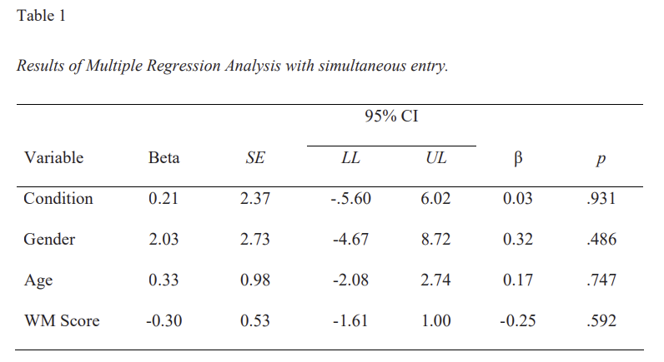
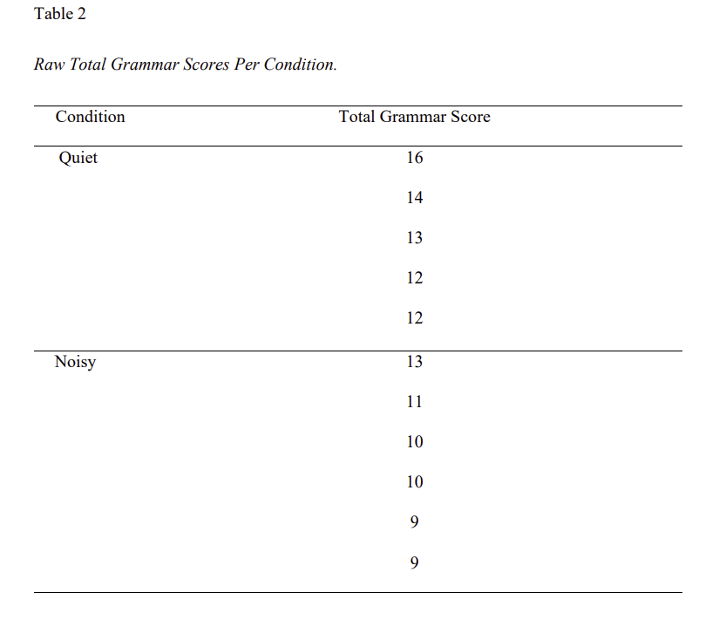

Psychology area:
Please Tick (or Cross) | Area
 | Clinical
 | Clinical – developmental
 | Cognitive
 | Cognitive - developmental
 | Cognitive - perception
 | Cognitive - psychopharmacology
x | Developmental
 | Developmental – neuropsychology
 | Forensic
 | Historical
 | Marketing
 | Modelling – computational
 | Neuropsychology
 | Psychopharmacology
 | Psychophysics
 | Social

Keywords:
Please Tick (or Cross) | Area
 | ANCOVA
 | ANOVA
 | Bayesian analysis
 | Chi-squared
 | Correlation
 | Factor analysis
 | Latent class analysis
 | Linear mixed effects modelling
 | Log-linear analysis
 | MANOVA
 | Monte Carlo simulations
 | Multi-dimensional scaling
 | Power analysis
 | Qualitative
 | Qualitative (Conversation analysis)
 | Qualitative (Discourse analysis)
 | Qualitative (Thematic analysis)
x | Regression
 | Signal detection theory
 | Structural equation modelling
 | t-test
Additional keywords: N/A
A description of methods taken, or that need to be taken, for data anonymisation:
Children were assigned numbers and all data was stored via REDCap where identifying information is stored in different encrypted files. Only age and gender were included, names were eliminated, participants were identified by their ID number which was only available to myself and my supervisor.
Please attach alongside this file, the following documents:
Attached? | Item
x | A blank consent form
x | A data file
SPSS used | Codebook

