Data Acquisition Form 2021
Project Title: Third Parties and Police Use of Lethal Force: Evidence from the Mapping Police Violence Database
Creator Name: Sian Reid
Date: 6th September 2023

Collection
Secondary Analysis

Abstract
Over recent years media coverage has highlighted the use of excessive force by some police officers. The use of lethal force towards black and other ethnic minority citizens has been identified as a cause for significant concern. Research in the bystander literature and in non-fatal force policing contexts has identified that third parties can have positive impacts in reducing the severity of these incidences. The role of third parties in fatal force events, however, has not been investigated. This is something which the current study seeks to address. The Mapping Police Violence database was used to identify a year’s worth of lethal force events in the US. Newspaper articles relating to these incidents have been coded in line with a predefined coding framework to examine the presence of third parties in these incidents, and the nature of any social relationships with third parties in relation to the type of lethal force utilised. The results revealed that third parties were present in just under half of incidences and that the presence of a third-party with a pre-existing social relationship to the citizen was associated with a lower likelihood of officers utilising forms of ‘less lethal’ force to the extent that it results in a citizen fatality. These findings highlight the potential importance of third parties in understanding the nature of lethal police citizen interactions, and also the potential protective role the presence of known others may have in reducing the likelihood of officers excessively utilising forms of less lethal force.

Keywords
Lethal force, Third Parties, Police Citizen Interactions, Use of Force

Method
A secondary data analysis was utilised to examine the presence of third parties in incidences of police use of lethal force. The Mapping Police Violence database (Mapping Police Violence, 2020) was the primary dataset utilised for the study. This is a freely available and open public database compiled by researchers in the US which aims to provide a record of all police involved deaths in the US. This database has been recording police involved deaths in the US since 2013, primarily gathering information through news articles published by various American news outlets. The type of force engaged in by officers that resulted in death was utilised as the outcome variable. The predictor variables were the presence of third parties, the presence of any known third parties, or unknown third parties, the number of officers present, the presence of other emergency services, the location of the incident, the race of the citizen, the gender of the citizen, the alleged presence of a weapon, the initial reason for the encounter, the presence of any digital technology capturing the event and the level of threat posed to the officer.
The Mapping Police Violence database records multiple variables in relation to these incidences, including individual and situational factors. Several of the predictor variables included in the current study have been gathered from this dataset; specifically, the type of lethal force used, the alleged presence of a weapon, the race of the citizen, the gender of the citizen, the level of threat posed to the officer, the initial encounter reason and the presence of a body worn camera. Within the current study, most of these variables have been used as recorded in the dataset, however, the level of threat posed to the officer has been recategorized. The multiple different levels of threat recorded in the dataset have been regrouped into three categories: attack (indicating the greatest level of threat to the officer), other (referring to any other level of threat), and none (for incidences in which it was clear there was no threat to the officer). In the original data only the presence of a body worn camera is recorded. For the current study this variable has been transformed to include the presence of any digital technology capturing the event, such as CCTV or smartphones, as research has found that the presence of any digital technology and not only a body camera can affect police citizen interactions (Shane et al., 2017).
The Mapping Police Violence database records the citizen’s cause of death in relation to the type of force utilised. In incidences where multiple types of force have been identified as contributing to the citizen’s death, the database records a list of all types of force involved. The types of force included in the database include gun, taser, pepper spray, baton and physical restraint. For the current study, these types of force have been grouped, to provide an outcome variable with fewer levels. The grouping of the outcome variable has been done in line with previous research looking at police use of force, which identified a gun as a distinct type of force due to the increased risk of lethal outcomes. The other types of force are grouped into a second category of other types of ‘less lethal’ force, as these types of force have been identified as alternatives to the use of a gun, which would be expected to reduce the likelihood of a citizen fatality (Sheppard & Welsh, 2022). In incidences where multiple types of force were used, the most severe form of force has been recorded; for example, if the cause of death is attributed to a gun and a taser, then this incident would be recorded as a gun as the type of lethal force utilised.
The dataset contains links to the news articles which have been used to gather information regarding each of the individual police involved death incidences. The variables included in the current study relating to the presence of others were gathered by coding these news articles which are linked in the database to the individual incidences of police involved deaths between 6th March 2022 – 6th March 2023, providing a sample of 1,257 police involved deaths. News articles are a source of information which have been identified as having certain limitations, particularly relating to potential media bias in the reporting of crime related stories (Lawrence, 2000). Research looking at the reporting of police use of force incidences by newspapers, however, has found that for many factors there was consistency between news reports and police reports of the same incidents (Ready et al., 2008). For the current study, news articles are utilised due to the promise they provide in allowing the events of police involved deaths to be examined in relation to the presence of third parties.
To identify the relevant incidences for the current study, three primary exclusion criteria were applied prior to the coding of the news articles. Firstly, to identify incidences with news articles with sufficient information to allow the presence of third parties to be examined, a minimum word count of 150 words was required in at least one of the associated news articles. Secondly, as the study’s primary interest was in the use of lethal force, which involves an on-duty officer using force, only incidences relating to on duty officers were included. Finally, incidences in which the use of force by the officer was accidental, such as car crashes that police officers were involved in, were excluded, as these events have different characteristics to those in which officers intentionally engage in the use of force towards a citizen. The application of these exclusion criteria left a sample of 1052 incidences of police use of lethal force.
To investigate the presence of others in these incidences, prior to the analysis a predefined behavioural coding scheme (Philpot et al., 2019) was created and applied to the news articles to capture the presence of third parties. This coding scheme contained 12 individual items capturing the presence of third parties and any social ties between third parties and the citizen involved in the incident (See Appendix A for the full coding scheme). Two additional items were included to capture the presence of multiple officers or other emergency services. One code regarding the location of the incident was also included to capture whether it occurred in a public, semi-public or private location. Each of the items were coded for presence with a 1, their absence recorded with a 0, or if it was not clear whether this item was present a 99 was recorded. In total 15 codes were included in this behavioural coding scheme. Here are some examples of these codes relating to the presence of third parties:
“The presence of a third-party with a pre-existing social connection to the primary citizen involved”
“The presence of more than one officer”
“The presence of a third-party with no pre-existing social connection to the primary citizen involved”
To facilitate the process of coding the news articles in line with the coding scheme, a Qualtrics survey (https://www.qualtrics.com) was created. This survey presented the individual items within the coding framework in a questionnaire format, allowing the items to be coded in the format of closed ended responses to questions relating to the presence of third parties. The responses from the survey were then transferred to an Excel document to allow the data to be prepared for analysis.
Ethical approval has been obtained for this study. The study has been reviewed and approved by a member of the Lancaster University Psychology Department, the ethics partner of the supervisors.
The reliability of the coding scheme and its application to the news articles was assessed through the double coding of 10% of the sample by a second researcher separately to the primary researcher. To assess the level of agreement between the two researchers for each variable, Gwet’s AC1 (Gwets, 2014) coefficient was calculated. In line with the recommendations of Landis and Koch (1977), the resulting coefficients were interpreted in the following way: a value of 0.4 or above indicating moderate agreement, a value of 0.6 or above indicating substantial agreement, and finally a value of 0.8 or above, indicating almost perfect agreement between raters’ scores. For 13 of the variables an agreement level of substantial or almost perfect was reached, as seen in table 1 (appendix B). For the variable relating to the third-party being a friend of the citizen there was no variation in responses (i.e., 100% agreement), and therefore a coefficient could not be calculated. For the location variable, only a moderate level of agreement was found, as a result this variable was excluded for the purpose of analysis.
Figure 1 depicts a flowchart of the process undertaken to sample the relevant incidences. The first part of the flowchart shows the initial process that was undertaken to identify all police involved deaths recorded in the Mapping Police Violence database in the prior 12 months. Following the initial data collection procedure descriptive statistics were run which highlighted that in the initial sample of 1052 incidences there was very limited variation in the outcome variable of the type of lethal force utilised by officers, with 990 incidences involving a gun as the primary cause of death, and only 62 incidences involving other forms of force. In this initial sample a citizen’s cause of death not involving a gun would statistically be considered a rare event, which would have presented challenges in utilising this variable as the outcome in any subsequent analyses. In line with the recommendations of research (Shaer et al., 2019), an oversampling approach was chosen to overcome the limitations of having a rare event in the outcome variable, with further incidences in the dataset that did not involve a gun as the cause of death being oversampled so at least 10% of the sample involved a cause of death other than a gun. As can be seen in figure 1, for these incidences to be as similar to the primary sample as possible, they were only sampled for the three preceding years to limit any additional sample variation that may have been introduced by sampling a wider date range. This led to the identification of a further 182 incidences where the citizen’s cause of death did not involve a gun. The same exclusion criteria were then applied to this sample, with a further 65 incidences excluded, leaving a sample of 117 additional incidences which were coded in line with the same procedure as the initial sample. This oversampling procedure led to a final sample of 1169 incidences.

Figure 1
A Flowchart of the Sampling Procedure

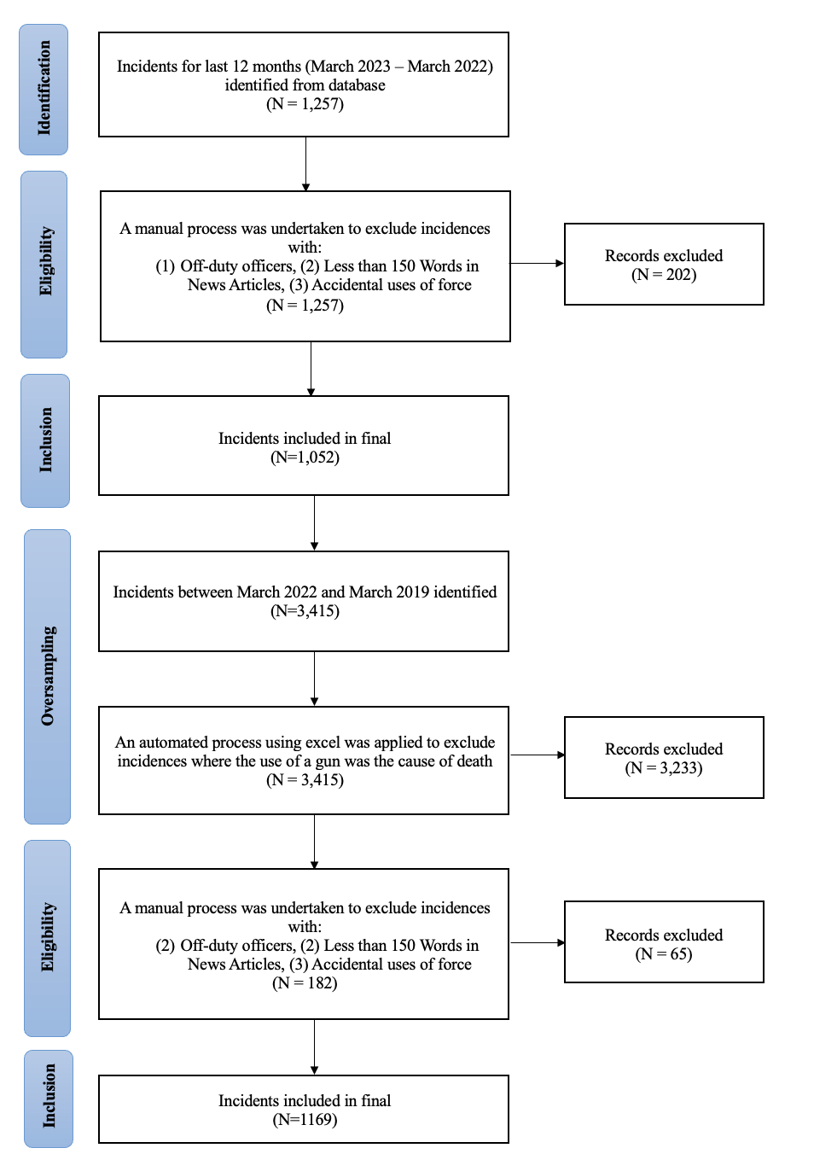

The data analysis involved chi square tests of independence, to examine whether the presence of others during fatal police citizen interactions had a statistically significant relationship with the outcome variable of the type of lethal force utilised by officers. Due to the exploratory nature of the study there was not a predicted direction or nature of the relationship between the predictor variables relating to third-party presence and the type of fatal force utilised by officers (McIntosh, 2017). Prior to the main analyses, descriptive statistics were run to investigate distributions within variables and to allow any rare event variables to be identified.

Results
For the purposes of analysis 1052 news articles were initially coded in line with a predefined coding framework to examine the presence of third parties during incidences of police use of lethal force. 27 incidences were excluded due to having a NA value in at least one of the variables of interest leaving an initial sample of 1025 incidences. Of the initial 1025 incidences, 988 involved a firearm as the type of lethal force utilised by officers. Within a single year a firearm was utilised as the type of lethal force by officers in 96% of incidences. Oversampling was undertaken in order for the final sample to have at least 10% of incidences involving a different type of lethal force. This oversampling led to a final sample of 1142 incidences with a further three excluded from the analyses due to having an NA value in at least one variable of interest, resulting in a final sample of 1139 incidences. Of the 1139 incidences included in the analyses, the use of a firearm as the type of lethal force occurred in 988 incidences, the use of less lethal forms of force such as a taser in 110, and the use of physical force in 41 of these incidences. Citizen Demographics and Incident Characteristics Descriptive statistics were calculated for the variables previously linked in the literature as being relevant to the police use of lethal force. Of the 1139 incidents, 21.6% involved encounters relating to the highest level of violent crime, 28.7% related to other violent crimes, 14.8% were welfare related, 15.1% were traffic stops and 19.8% involved other reasons for the encounter. Looking at the citizen’s gender, 1079 incidents involved male citizens. With regard to citizen ethnicity, 421 were white, 279 black, 187 of another ethnic group (Asian, Hispanic, Native Population) and for 249 incidents there was not enough information available to determine the citizen’s ethnicity. In 86.7% of the incidents, the primary citizen was allegedly armed and 45.5% of the incidents were captured by some form of digital surveillance. Finally, with regards to the level of threat posed to the officer, in 21.7% of the incidents the ‘attack’ level of threat was present, with 73.4% involving a lesser level of threat and 4.9% involved no clear threat to the officer. Figure 2 depicts six graphs which show the proportions of each of these variables in relation to the type of lethal force utilised in each incident. As can be seen, a higher proportion of black citizens were victims of the other forms of ‘less lethal’ force, than were victims of a gun; comparatively a higher proportion of white citizens were victims of a gun compared to other forms of ‘less lethal’ force. A higher proportion of violent crime related encounters resulted in the use of a firearm by the officer, than other forms of force. In incidences where a firearm was used by officers, 89% of citizens were allegedly armed compared to only 75% in incidences where other forms of lethal force were utilised. Almost 50% of firearm incidences were captured by some form of digital surveillance, with a lower proportion of incidences involving other forms of lethal force captured. These initial findings highlight that the distributions of these predictor variables were not all equivalent across the types of lethal force. Previous research looking at the characteristics of police use of force has highlighted that black and ethnic minority citizens are at a greater risk of being involved in these police incidences (Edwards et al., 2019). In the current study Pearson’s chi-square tests were conducted, to assess ethnic variation in the proportions of citizens killed by the Police captured in the current data, and the proportions of the general US population utilising the 2020 US census data (U. S. Census Bureau, 2020). The proportion of all three groups (White, Black and Other), were significantly different when comparing their proportions in the Mapping Police Violence database and the US census data. The proportion of white individuals represented in the US census data was greater than the proportion represented in the Mapping Police Violence data, X² (1, N = 204,838,287) = 184.77, p <.001. The proportion of black individuals represented in the US census data was smaller than the proportion represented in the Mapping Police Violence data, X² (1, N = 41,333,194) = 238.28, p <.001. The proportion of individuals of other ethnicities (Asian, Hispanic, Native populations) represented in the US census data was also smaller than the proportion represented in the Mapping Police Violence data, X² (1, N = 53,079,833) = 6.50, p = .012. These results are consistent with the findings of previous research that black and ethnic minority citizens appear to be disproportionately affected by the police use of lethal force. A Pearson’s chi square test of association with a Cramer’s V measure of effect size, was conducted to assess whether differences arose in the types of lethal force utilised by officers towards the different ethnic groups represented in the incidences. For this analysis, citizens whose ethnicity was recorded as unknown in the dataset were excluded, providing a sample of 890. The citizen’s ethnicity was significantly associated with the type of lethal force utilised by officers, X² (2, N = 890) = 7.59, p =.022, V = .10. Particularly, a greater proportion of black citizens were killed by other forms of force such as tasers and physical restraint than would be expected if a citizen’s ethnicity had no relationship to the type of lethal force utilised by officers. White citizens also represented a greater proportion of those citizens killed by gunfire than would be expected if the citizen’s ethnicity had no relationship to the type of lethal force utilised. These results highlight that black citizens appear to be at a heightened risk of having other forms of ‘less lethal’ force perhaps excessively applied compared to white citizens. Next, it was assessed whether other individual and situational predictor variables were significantly associated with the type of lethal force utilised by officers. This included presence of digital technology capturing the event, the gender of the citizen, the initial reason for the encounter, the level of threat to the officer and whether the citizen was allegedly armed were all individually assessed in relation to the outcome variable of the type of lethal force. Pearson’s chi square tests of association found the presence of digital surveillance, X² (1, N = 1139) = 17.11, p<.001, V = .13, the citizen being allegedly armed, X² (1, N = 1139) = 17.11, p<.001, V = .16, the citizens gender, X² (1, N = 1139) = 8.00, p = .005, V = .09, the initial encounter reason, X² (5, N = 1139) = 143.96, p <.001, V = .36, and the level of threat posed to the officer, X² (2, N = 1139) = 117.58, p<.001, V = .32, were all significantly associated with the type of lethal force utilised by officers. These results indicate that all five variables are significantly associated with the type of lethal force utilised. Third Party Presence Table 2 shows the descriptive statistics relating to the presence and types of present third parties. The statistics highlight that nearly 45% of incidences of police use of lethal force occurred in the presence of a third-party member of the public. Further it can be seen that the presence of a third-party was fairly consistent across the types of lethal force, with just under half of incidences involving each type of force occurring in the presence of a third-party. Looking at the social relationships of these third parties to the victim, 315 incidences occurred in the presence of known third parties and 188 occurred in the presence of unknown third parties. Multiple officers were present in just over 90% of incidences, whereas other emergency services were only present in just over 4% of the incidences. To assess the relationship between the presence of third parties and the type of lethal force utilised by officers, Pearson’s chi-square tests were again conducted. Separate analyses were conducted for each of the five variables relating to third-party presence: any public third-party, known others, unknown others, multiple officers and other emergency services. Chi-square goodness of fit tests were also conducted, to assess whether there were significant differences between the distributions of the third-party variables across the types of lethal force and the expected distributions based on the proportions the different type of lethal force events represent. The results of these analyses revealed that the mere presence of a third-party was not significantly associated with the type of lethal force utilised by officers, X² (1, N = 1139) = 0.09, p = .759, V = .01. Further to this the presence of unknown third parties, X² (1, N = 1139) = 0.45, p = .502, V = .02, multiple officers, X² (1, N = 1139) = 1.18, p = .277, V = .04, or other emergency services, X² (1, N = 1139) = 1.77, p = .184, V = .05, were also not significantly associated with the type of lethal force utilised by officers. For these variables there was not a significant difference between the expected and observed values relating to the presence of third parties and the type of lethal force utilised by officers. There was however, a weak but significant association between the presence of known third parties and the type of lethal force utilised by officers, X² (1, N = 1139) = 10.90, p = .001, V = .10. The observed values for the presence of known others were significantly different from the expected values in relation to the type of lethal force utilised by officers, with a lower proportion of incidences involving forms of lethal force other than a firearm occurring in the presence of known others than would be expected if the presence of known others had no relationship with the type of lethal force utilised. These results highlight that the presence of known others in these incidences, may be a protective factor for the likelihood of a citizen being the victim of the excessive use of forms of force other than firearms.

Format of data
Excel.csv
r_file. R

Rights
Open

Relation
N/A

Language
English
Type
Data

Supervisor Name: Prof. Mark Levine and Dr. Richard Philpot

Project Level
☐Undergraduate
☒Masters

Topic
Please select all the sub-categories of Psychology that the project falls under
☐Clinical
☐Clinical, Developmental
☐Cognitive, Developmental
☐Cognitive, Perception
☐Cognitive, Psychopharmacology
☐Developmental
☐Developmental, Neuropsychology
☐Forensic
☐Historical
☐Marketing
☐Modelling (Computational)
☐Neuropsychology
☐Psychopharmacology
☐Psychophysics
☒Social
☐Other
If you selected “Other” and the topic of your project is not listed above, please state your topic(s) in this box

Sample Size: 1169 incidents examined

Statistical Analysis Type
Please select all the types of statistical analysis used in your project
☐ANCOVA
☐ANOVA
☐Bayesian Analysis
☒Chi-Squared
☐Correlation
☐Factor Analysis
☐Latent Class Analysis
☐Linear Mixed Effects Modelling
☐Log-Linear Analysis
☐MANCOVA
☐Monte Carlo Simulations
☐Multi-Dimensional Scaling
☐Power Analysis
☐Psychometrics
☐Qualitative
☐Qualitative (Conversation Analysis)
☐Qualitative (Discourse Analysis)
☐Qualitative (Thematic Analysis)
☐Regression
☐Signal Detection Theory
☐Structural Equation Modelling
☐T-Test
☐Other
If you selected “Other” and the statistical analysis used in your project is not listed above, please state your analysis/analyses in this box

Data Files
Please ensure that you attach the documents listed below alongside your data acquisition form and provide the names of the files for ease of identification.
Blank Consent Form: N/A
Data File(s): Mastersdata.csv
Codebook: Codebook.txt
Data Analysis Code: MastersScript.R

For additional information, user guides and updates please visit https://wp.lancs.ac.uk/lustre/

